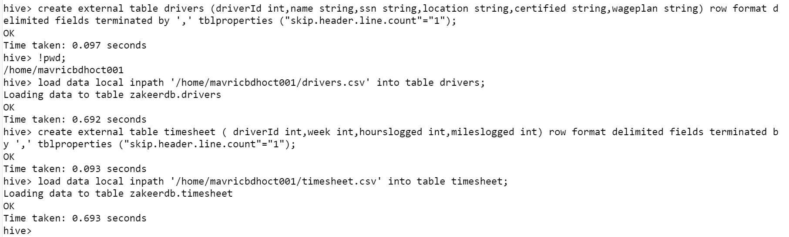

How many total hours and miles logged by each driver?

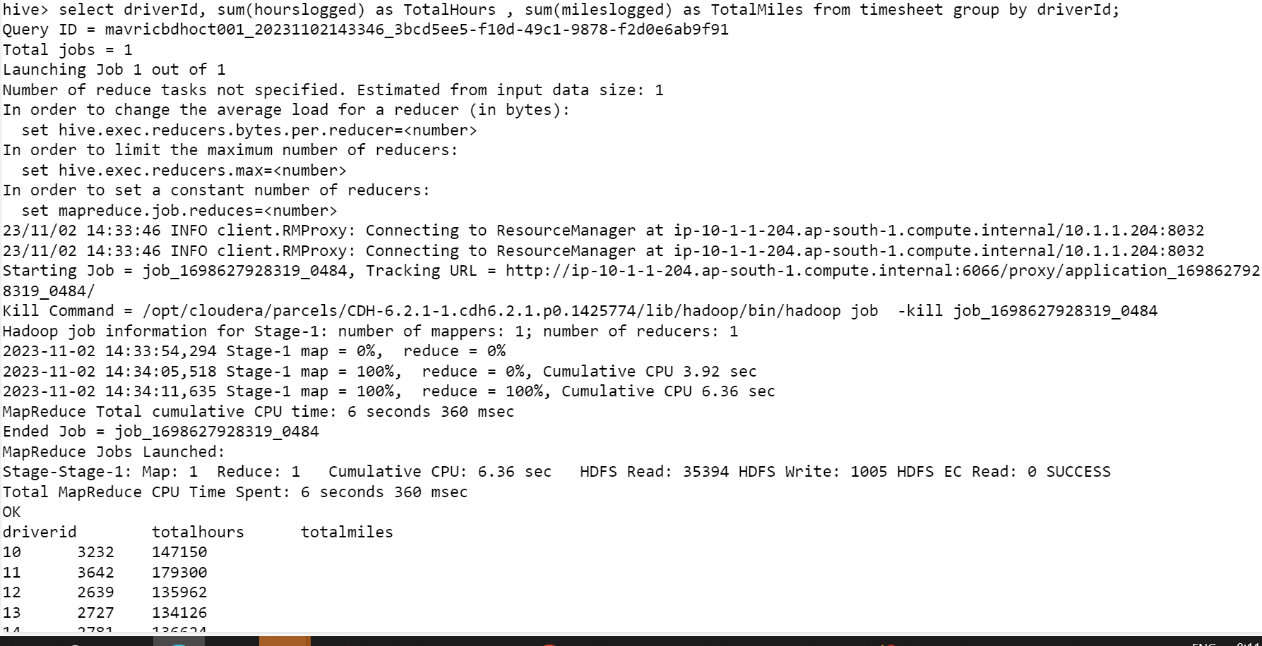

Q2) Print the name of the driver in the above query



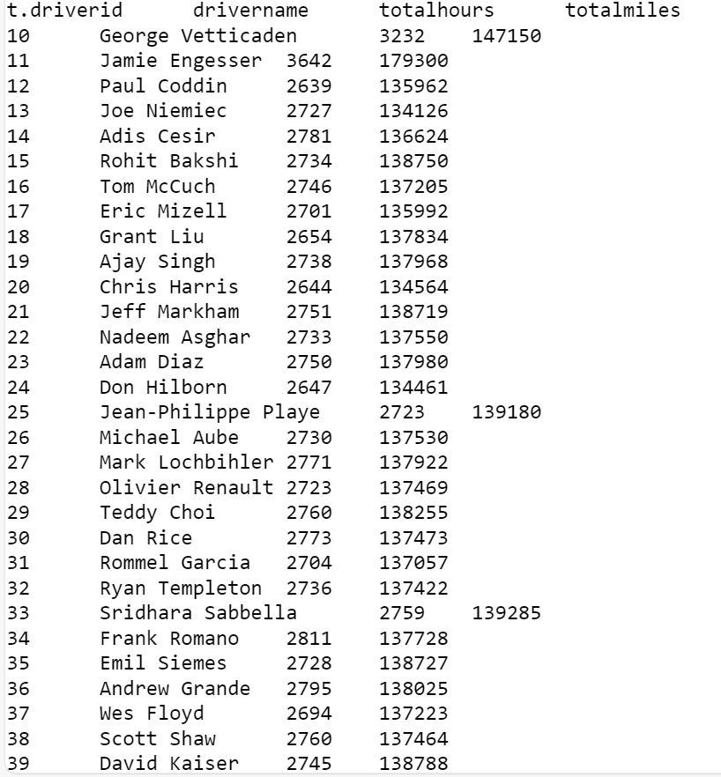

Q3) Write the above query output in to hdfs directory



